

# SHALE PIZZA

**Supervisor:** *NGUYỄN HẠ VY*

**Semester:** *01*

**Batch No:** *T1.2208.M2*

**Group No:** *01*

|  |  |  |
| --- | --- | --- |
| **Order:** | **Full name** | **Roll No.** |
| *1.* | *HỨA TRƯỜNG AN* | Student1414334 |
| *2.* | *LÊ BÁ THÀNH* | Student1409136 |
| *3.* | *NGUYỄN VĂN THÂN* | Student1414346 |
| *4.* | *TRẦN CAO MINH ĐỨC* | Student1414362 |

***Month****: 11* ***Year****: 2022*



This is to certify that

**Mr. HỨA TRƯỜNG AN Mr. LÊ BÁ THÀNH Mr. NGUYỄN VĂN THÂN**

**Mr. TRẦN CAO MINH ĐỨC**

Have successfully Designed & Developed

# SHALE PIZZA

Submitted by:

**Ms. NGUYEN HA VY**

Date Of Issue:

Authorized Signature:

# Content

Content Acknowledge Synopsis

Review 1

Review 2

Review 3 ..

Tasksheet ..

# Acknowledge

As we understand that the eProject is a step-by-step learning environment that closely simulates the classroom and Lab-based learning environment into actual implementation. It is a project implementation at your fingertips!! An electronic, live juncture on the machine that allows you to.

* Practice step by step i.e. laddered approach.
* Build a larger more robust application.
* Usage of certain utilities in applications designed by user.
* Single program to unified code leading to a complete application.
* Learn implementation of concepts in a phased manner.
* Enhance skills and add value.
* Work on real-life projects.
* Give a real-life scenario and help to create applications that are more complicated and useful.
* Mentoring through email support.

First of all, I would like to thank India Aptech for allowing my team to work on this fantastic eProject. We had a great experience with eProject this time.

Next, We would like to express my special thanks to our mentor, Ms. Ha Vy for the time and effort that she provided throughout the project. Your helpful advice and suggestions were beneficial to us during the completion of the project. In this respect, We are forever grateful to you.

Besides several mistakes we made in the project, we hope to have more opportunities to widen our knowledge in the web-developing world.

We will try to continue to learn and improve ourselves even more in the future.

Yours Sincerely, Team Group 01.

# Synopsis

The Objective of this program we aim is to give a sample project to work on real- life projects. These applications help us build a larger more robust application.

The objective is not to teach us HTML/JavaScript but to provide us with a real-life scenario and help us create basic applications using the tools.

Hence, we can revise the chapters before we start with the project.

This project is meant for students like us who have completed the module of HTML5. These programs should be done in the Lab sessions with the assistance of the faculty if required.

The website (in this project) is a tool that brings everything in the world to you such as historic monuments information natural knowledge and skill in technology...

It is very essential for us that will have a clear understanding of the subject. We think we should go through the project and solve the assignments as per the requirements given.

And get back [***eprojects@aptech.ac.in***](mailto:eprojects@aptech.ac.in) as the assigned schedule.

## Problem Definition

Shale-PIZZAAsss is famous for Pizzas, Pasta food. Shale-PIZZAAsss was opened with

one restaurant in the year 1960 and now it has more than 1000 restaurant across

the countries. A website needs to be designed must display the menus, Contact Us

(so as to call a make order). Details of various franchise, locations, feedback must be

included.

The website is to be developed for the Windows Platform using HTML5, JavaScript

and Geolocation. The site should work well in all leading browsers including Chrome,

IE, Firefox etc.

**Requirement Specification:**

The Web site is to be created based on the following requirements.

1) Home Page must display the image section of the website.

2) Color combination must be made precise in the application.

3) Links such as

- Home

- Menu

i. Pizza

ii. Garlic Breads

iii. Pizza Sandwiches

iv. Desserts

v. Beverages

- Menu Download

- Store Location

- Locations

- Feedback

- Franchise Info

4) There should be a “Contact Us” page which will have the Address of the

Company which should be displayed using GeoLocation API (eg. GoogleMaps)

and the email address which when clicked will invoke the local mail client

from where they can send an email.

5) Other Additional Links such as

- Weekend Special

- Combo offers

- Gallery

6) Navigation of the project must be made precise

7) Look and feel must be made user friendly.

## Customer Requirements Specifications

### User:

#### input:

* Information on search.
* Data of registered members.
* Feedback to the webmaster.

#### Process:

* Find the searching
* Check the data of registered members.
* Check the feedback of users.

#### Output:

* Result of searching.
* Confirm the data of registered members.
* Confirm the feedback of the users.

### Hardware/ software requirement:

#### Software:

* + Notepad/HTML editor
  + Dreamweaver
  + IE 5.0/ Netscape 6.0

#### Hardware:

* + A minimum computer system that will help you access all the tools in the courses is a Pentium 166 or better
  + 64 Megabytes of RAM or be

Home

|  |  |
| --- | --- |
| **Document Name**:  Architecture and design of the project | **SWD/Form** No.03/ARD/Ver1.0 |
| **Version** 1.0 | **Page 3** |

User

Blog

Contact Us

Menu

About Us

Shopping Cart

Menu Download

Feedback

Location

Blog Details

Login

Register

1. **Interactive with web at Homepage**

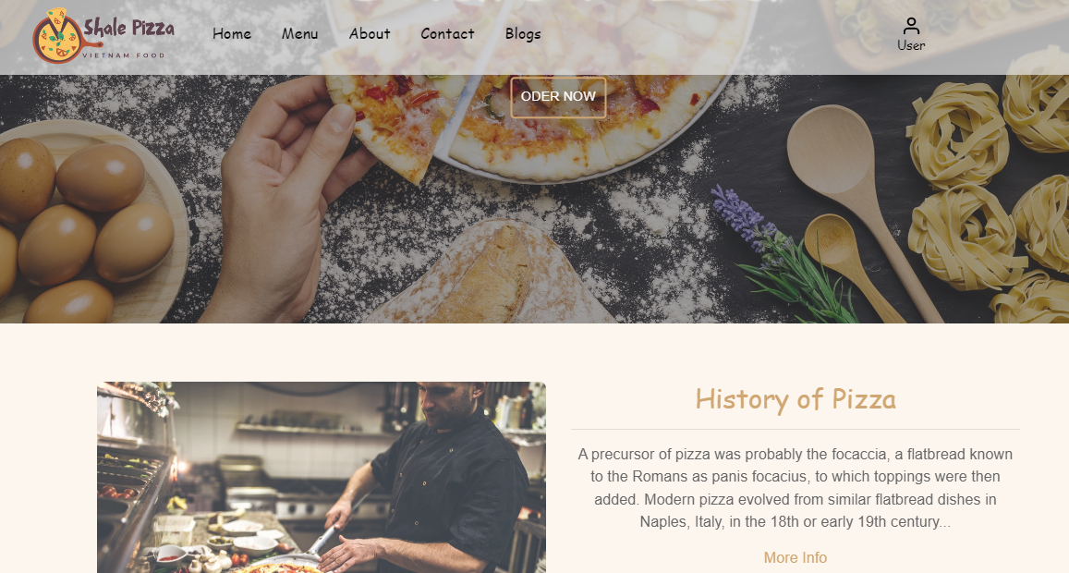



* + When you click icon , it will go to Menu. You can see it in “Menu”.
  + When you click “More info”. You go About page.

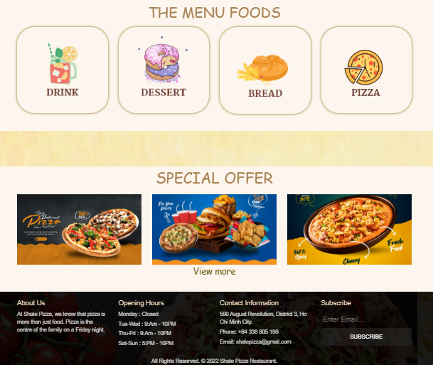

* + When you click icon “DRINK”, “DESSET”, “BREAD”, “PIZZA”. You go to Menu Food same drink, dessert, bread, pizza.

1. **Menu**
   * When you click icon “DRINK”, “DESSET”, “BREAD”, “PIZZA”. You go to Menu Food same drink, dessert, bread, pizza.

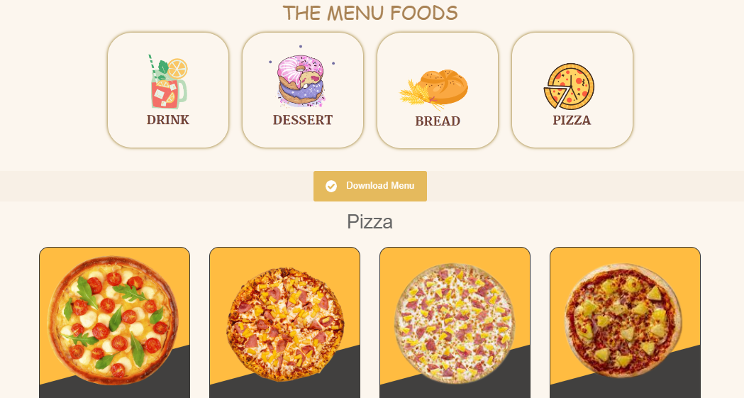

* + When you hover image of food:

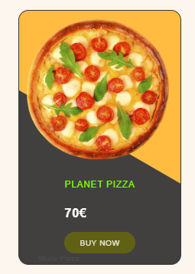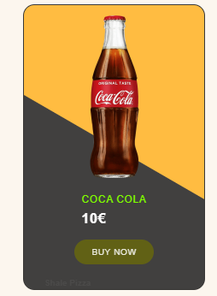

* + When you click img, go to page product details:

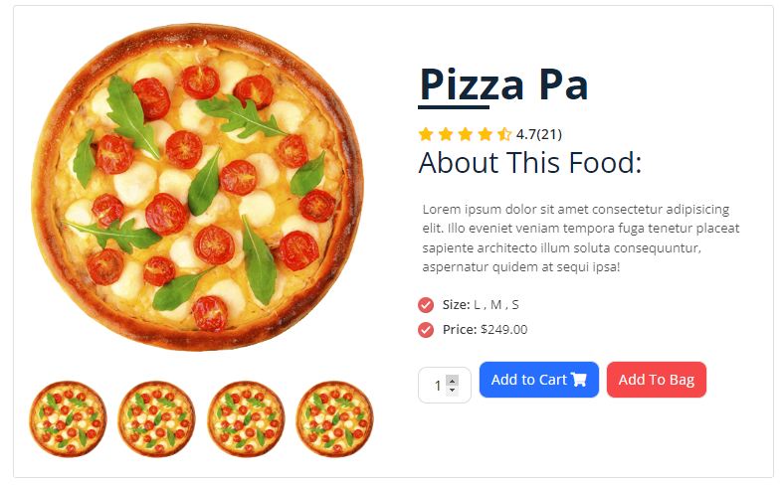

* + You can chose amount

1. **About**

About us page have:

* + Our story, our vision and a little information about stores:

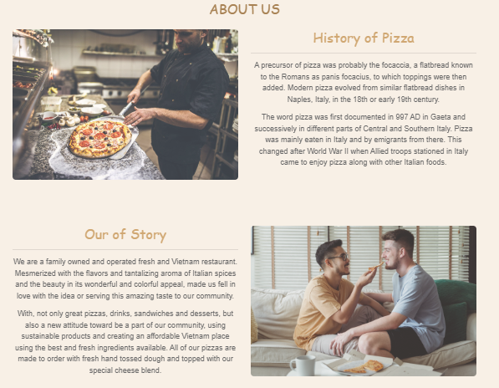

* + Store branch location and group member:

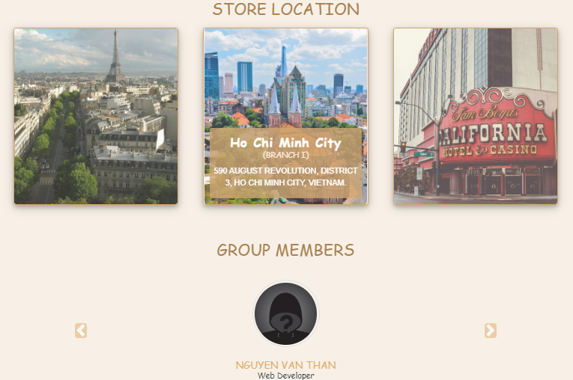

1. **Contact**

Contact page about:

* + Form that you can use contact with store.

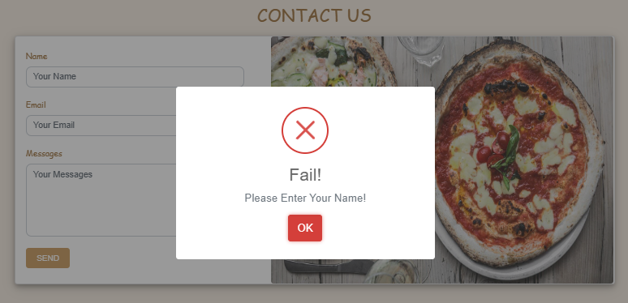

* + Location Store

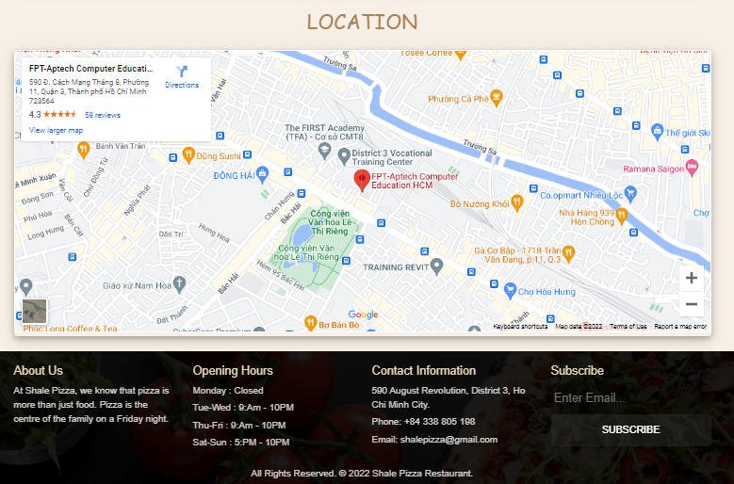

1. **Blog**

Blog page about:

* + Blogs and Blogs details.

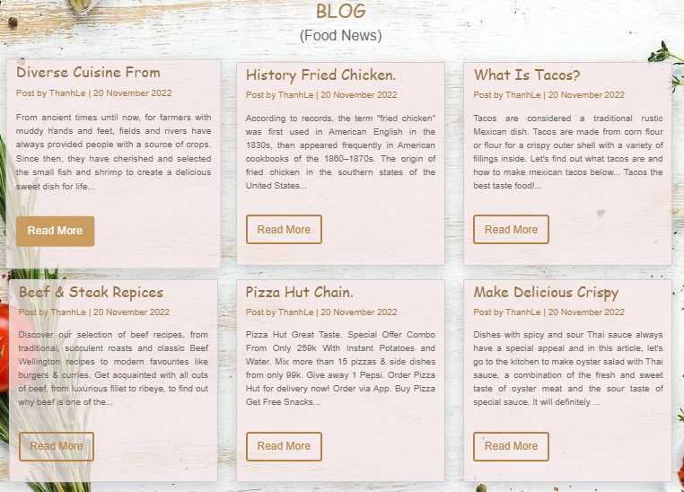

* When you click “Read more”

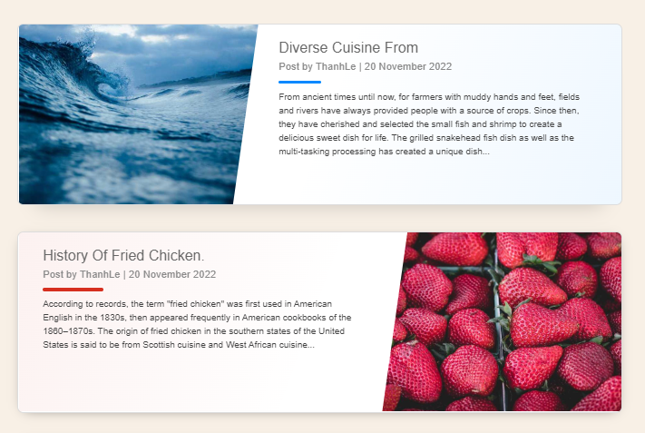

1. **Login/Signup**
   * Login form and if login success.

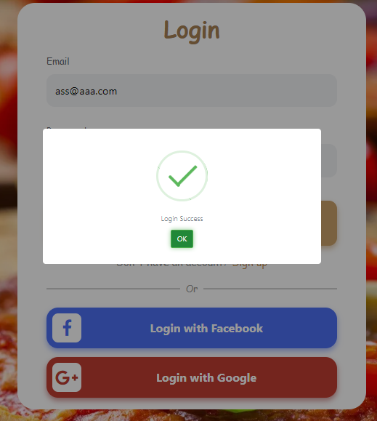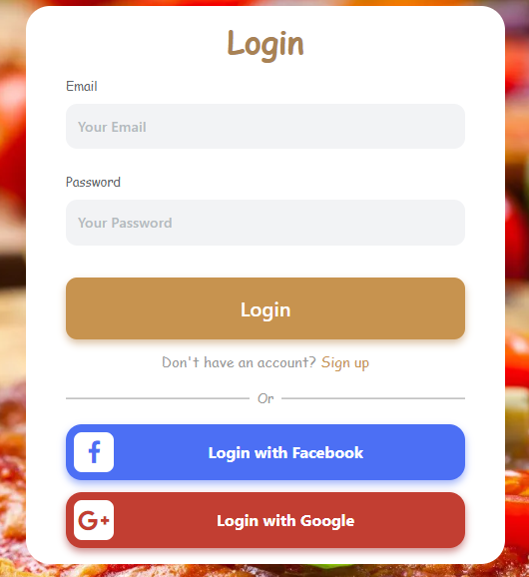

* + Signup form:

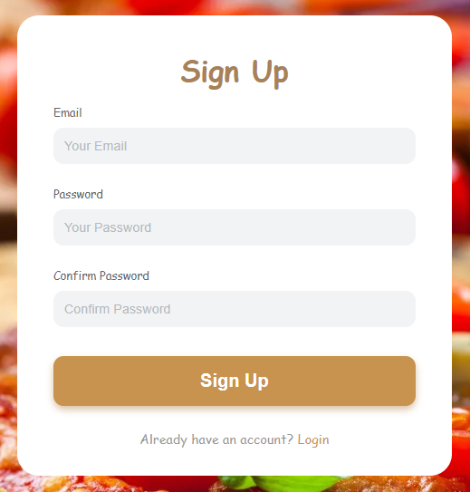

Task sheet

|  |  |  |  |  |  |  |  |
| --- | --- | --- | --- | --- | --- | --- | --- |
| No | Member | Contents | Page Name | Activity Plan | Date of Preparation of Activity Plan | | |
| Planed Start Date | Actual Start Date | Actual End Date | Status |
|  | Hứa Trường An | Home page | index.html | 16/11/2022 | 20/11/2022 | 15/12/2022 | 100% |
| Blog Details | Blog-details.html | 17/11/2022 | 21/11/2022 | 15/12/2022 | 100% |
| Blog | detail.html | 18/11/2022 | 21/11/2022 | 15/12/2022 | 100% |
|  | Nguyễn Văn Thân | Menu | Menu.html | 18/11/2022 | 21/11/2022 | 15/12/2022 | 100% |
| Login | login.html | 18/11/2022 | 21/11/2022 | 15/12/2022 | 100% |
| Signup | SignUp.html | 18/11/2022 | 21/11/2022 | 15/12/2022 | 100% |
|  | Lê Bá Thành | Menu | menu.html | 18/11/2022 | 21/11/2022 | 15/12/2022 | 100% |
| Cart | cart.html | 17/11/2022 | 20/11/2022 | 15/12/2022 | 100% |
|  | Trần Cao Minh Đức | Contact | contact.html | 18/11/2022 | 20/11/2022 | 15/12/2022 | 70% |
| About | about.html | 18/11/2022 | 21/11/2022 | 15/12/2022 | 70% |
| Signup | SignUp.html | 18/11/2022 | 21/11/2022 | 15/12/2022 | 70% |